PAYROLL PROCESSING APPLICATION

Use Case Diagram: Use Case View / User
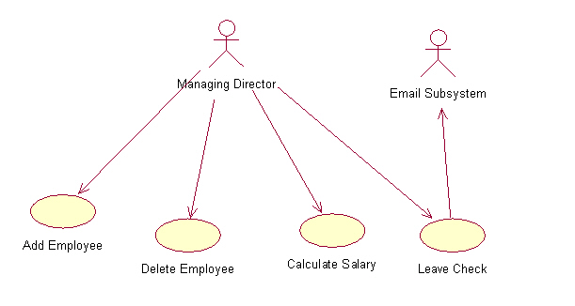

Activity Diagram: Calculate Salary / Calculate Salary
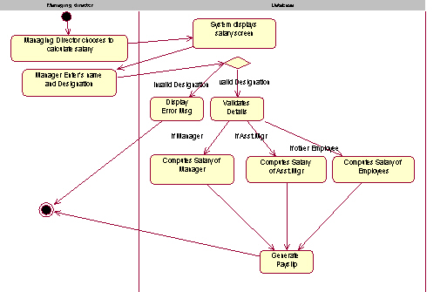

Activity Diagram: Add Employee / Add Employee
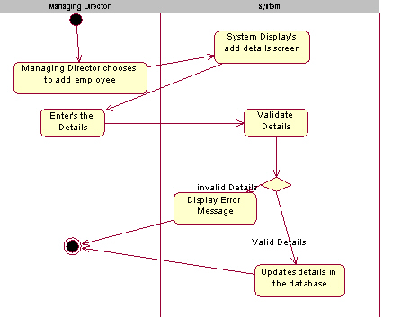

Activity Diagram: Delete Employee / Delete Details
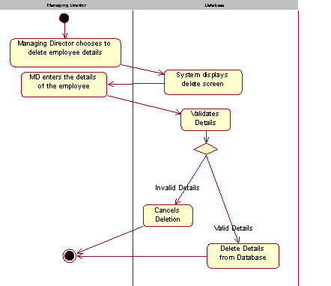

Class Diagram: Add Employee / Add-VOPC

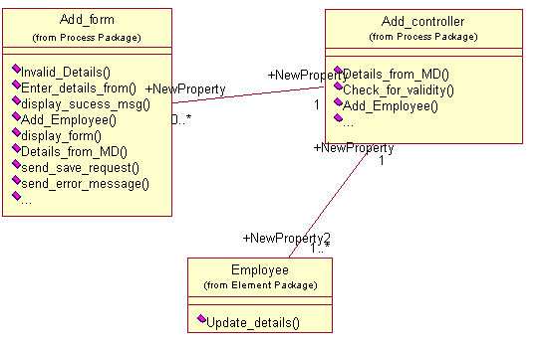

Collaboration Diagram: Add salary / Add

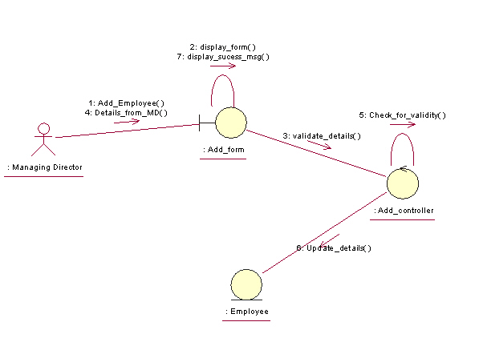

: Add salary / Add

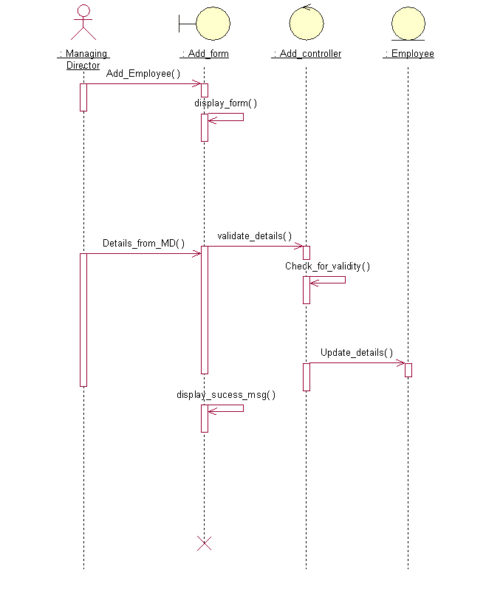
: Add salary / Add alternate
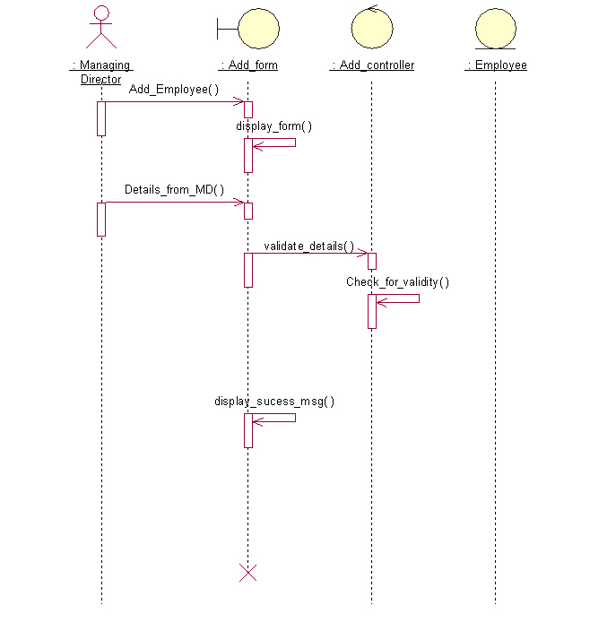

Collaboration Diagram: Add salary / Add alternate
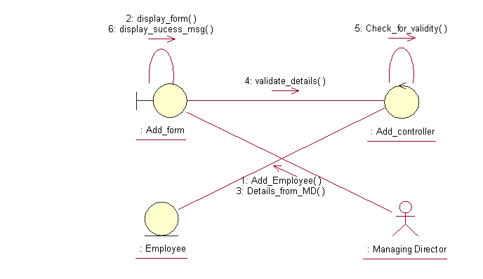

Class Diagram: Delete Employee / Delete VOPC
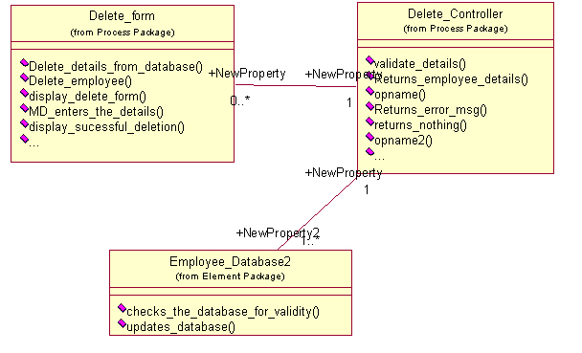

: Delete / Delete Employee
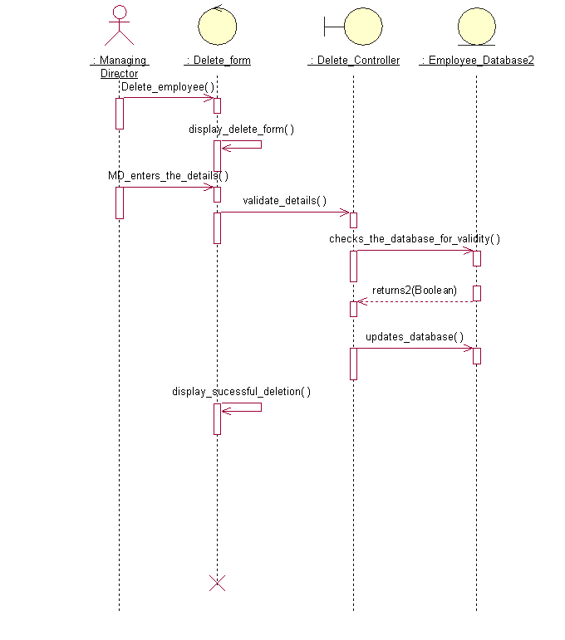

Collaboration Diagram: Delete / Delete Employee
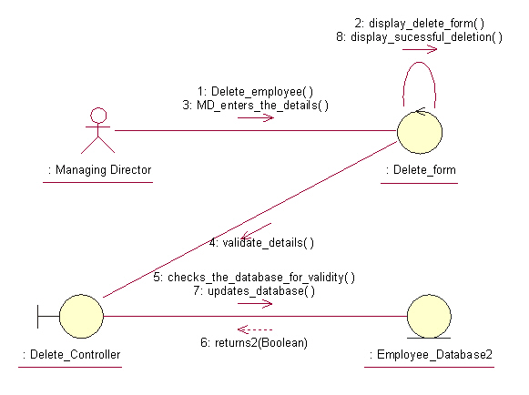

: Delete / Delete Alternate flow
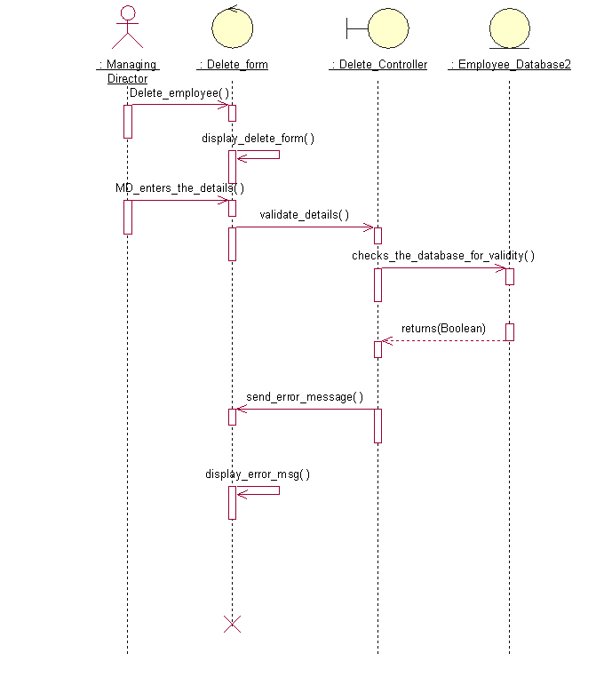

Collaboration Diagram: Delete / Delete Alternate flow
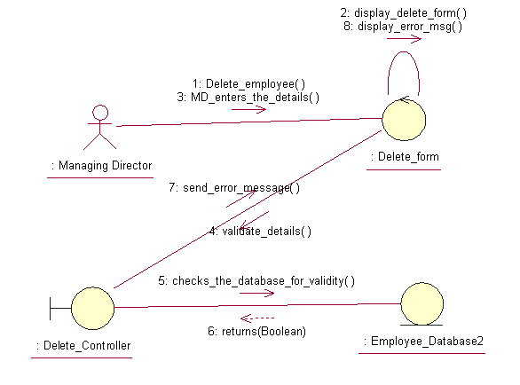

Class Diagram: Calculate salary / Calculate VOPC
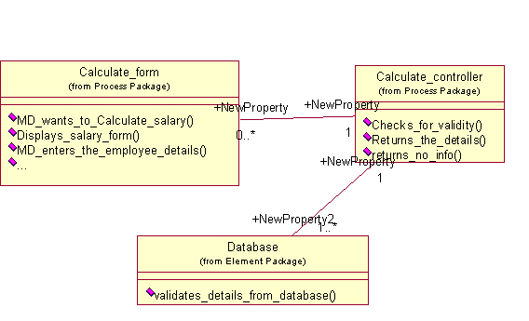

: Calculate / Cal basic flow
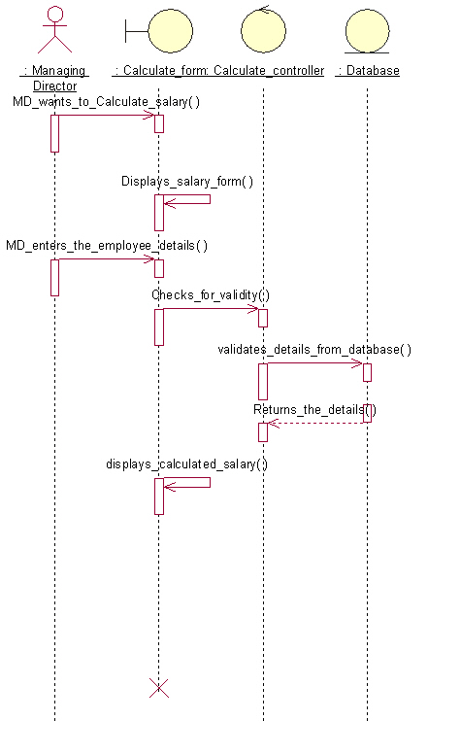

Collaboration Diagram: Calculate / Cal basic flow
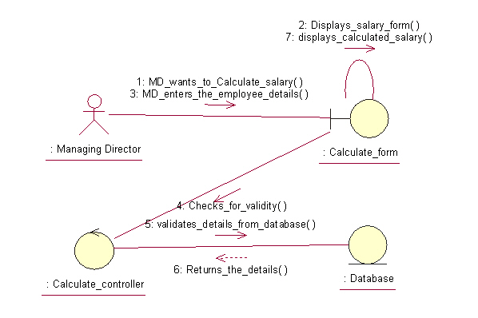

: Calculate / Cal alternate flow
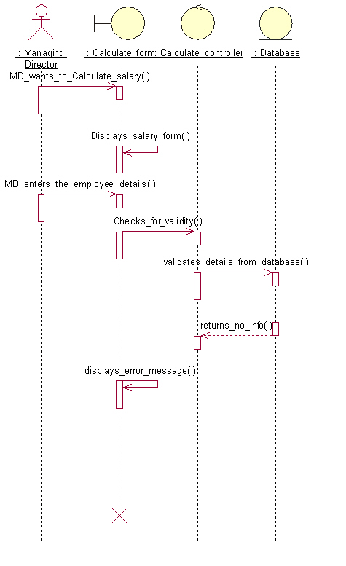

Collaboration Diagram: Calculate / Cal alternate flow
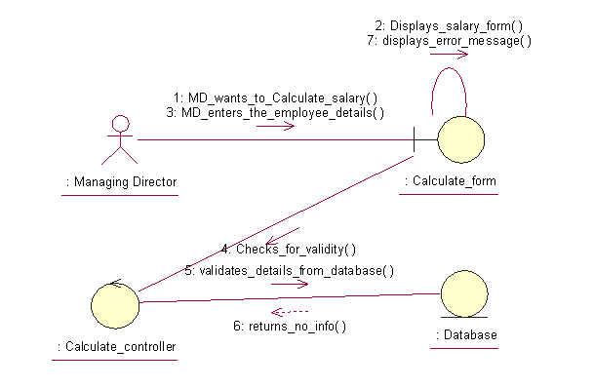

Class Diagram: Logical View / Main
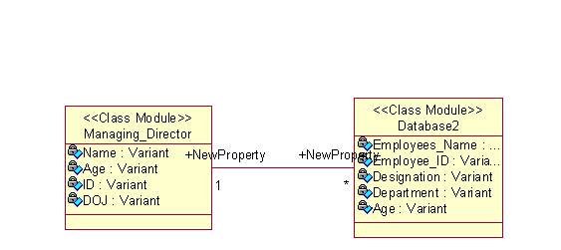

Class Diagram: Logical View / Key Abstraction
